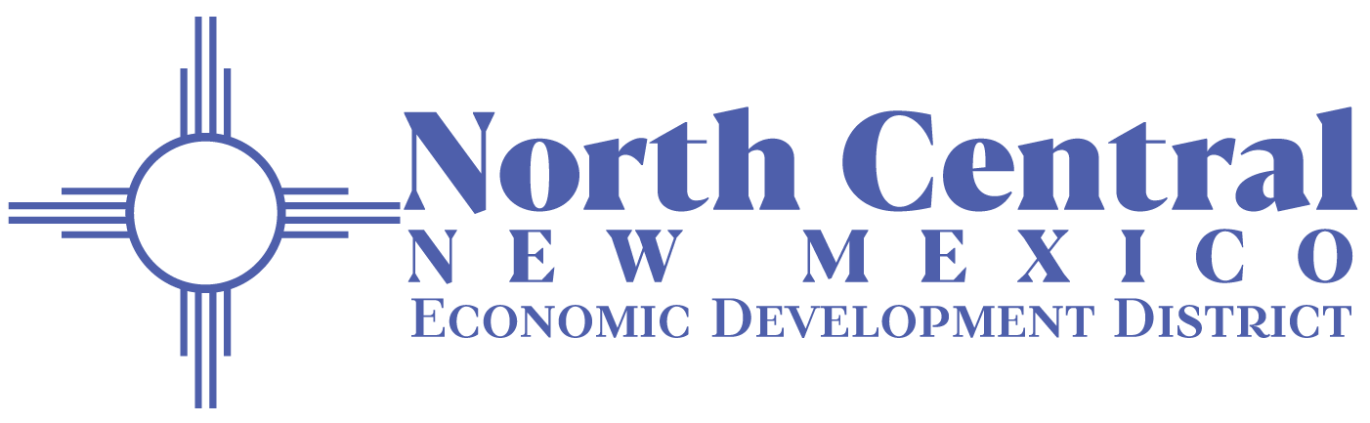

Executive Committee Regular Meeting Agenda

Thursday, February 26, 2026, 10:30 am or Immediately Following NM Cares Board Meeting
644 Don Gaspar, Santa Fe, NM, 87505
Or Virtual Option via Zoom: https://us02web.zoom.us/j/82995230719
Meeting ID: 829 9523 0719, Dial In: 1-719-359-4580

- CALL MEETING TO ORDER

- ROLL CALL

- APPROVE AGENDA

- APPROVE MINUTES
  - January 29, 2026, Regular Meeting

- PUBLIC PARTICIPATION: Any individual who would like to address the Board will be able to do so at this time. Comments will be limited to 3 minutes. If further time is needed, concerns should be addressed to the Executive Director. Personnel matters will not be discussed in a public meeting.
  - Staff
  - Community
    - If attending virtually, provide your full name in the chat and indicate that you wish to speak for public participation immediately upon joining the meeting.
    - If attending in person, raise your hand to indicate you wish to speak for public participation and provide your full name.

- EXECUTIVE SESSION
  - Board may elect to go into executive session for reasons listed in the Open Meetings Act, Section 10-15-1 (H). The authority for the executive session and the subject to be discussed must be stated with reasonable specificity in the motion calling for the vote to go into executive session.
    - Limited Personnel Matters Section 10-15-1(H)(2)-Executive Director Transition

- ACTION ITEMS
  - Out of State Travel Requests
    - US Aging, July 18-21, 2026, San Diego CA (Senior Housing Specialist, Denise Barela, VDP Coordinator Erin Carlisle, Case Management Coordinator Amanda Martinez, Case Management, Andrew Roybal, PSA3 Provider Specialist Ashley DiMascio, PSA3 Provider Specialist Monica Jimenez, Data Center, Consumer Coordinator Data Center Raquel Martinez, PSA2 Provider Specialist Dyami Brycela, Alternates, Director Danny Osborn, Data Center Manager Davida Salas)
    - SWREDA Annual Conference, Austin TX (Executive Director Santiago Chavez and Community Planner Selma Guiterrez)
  - Resolution 2026-04 North Central New Mexico Economic Development District to Apply for NMFA Solar Access Fund Technical Assistance Grant

- DISCUSSION ITEMS
  - Legislative Update
  - Finance Update
  - AAA Update

- PRESIDENT’S REPORT

- DIRECTORS’ REPORTS

- NEXT MEETING –March 25, 2026, 9:00 am

- ADJOURNMENT
Pursuant to the Americans with Disabilities Act (ADA) of 1990, if anyone requires assistance, please contact us at (505) 395-2668 or ncnmedd@ncnmedd.com at least three days prior to the meeting date.

