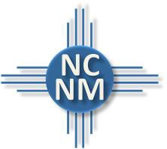
NORTH CENTRAL NEW MEXICO
ECONOMIC DEVELOPMENT DISTRICT
Executive Committee Special Meeting Agenda

Thursday, January 8, 2026, 2:00 pm
NCNMEDD Conference Room, 644 Don Gaspar, Santa Fe NM, 87505
Or Virtual Option via Zoom: https://us02web.zoom.us/j/84005284299
Meeting ID: 868 3638 7442, Dial In: 1-719-359-4580

- CALL MEETING TO ORDER

- PLEDGE OF ALLEGENCE

- ROLL CALL

- APPROVE AGENDA

- EXECUTIVE SESSION
Board may elect to go into executive session for reasons listed in the Open Meetings Act, Section 10-15-1 (H). The authority for the executive session and the subject to be discussed must be stated with reasonable specificity in the motion calling for the vote to go into executive session.
  - Limited Personnel Matters Section 10-15-1(H)(2)-Executive Director Transition

- NEXT MEETING –January 29, 2026, 9:00 am

- ADJOURNMENT
Pursuant to the Americans with Disabilities Act (ADA) of 1990, if anyone requires assistance, please contact us at (505) 395-2668 or ncnmedd@ncnmedd.com at least three days prior to the meeting date.

